WP Carey Salesforce Org Assessment

**W.P. Carey**

Salesforce Org Assessment

*Version 1.0*

*July 26, 2022*

Contents

Table of Contents

1 INTRODUCTION Error! Bookmark not defined.

1.1 Introduction 4

1.2 scope of assessment 4

1.3 methodology 4

1.4 findings 4

2 org summary 5

2.1 org limits 5

2.1.1 Data Storage 5

2.1.2 Data Storage Observations 6

2.1.3 File Storage 6

2.1.4 File Storage Observations 6

2.1.5 Daily API Requests 6

2.1.6 Daily API Requests Observations 7

2.1.7 Daily API Requests Recommendation 7

3 security 8

3.1 release updates 8

3.1.1 Release Updates Recommendation 8

3.2 profile permissions 9

3.2.1 Profile Permissions Recommendations 9

3.3 user provisioning 9

3.3.1 User Provisioning Recommendations 10

3.4 system administrator audit 10

3.4.1 System Administrator Recommendations 11

3.5 allowed email domains 11

3.5.1 Allowed Email Domain Recommendations 12

3.6 single sign on and multifactor authentication (mfa) 12

3.7 org wide default sharing model 12

3.7.1 Org Wide Default Recommendations 13

4 apex code 15

4.1 code quality 15

4.1.1 Apex Code Recommendations 15

4.2 test code coverage 16

4.2.1 Apex Code Recommendations 16

5 sandbox and deployment strategy 17

5.1 sandbox usage 17

5.1.1 Sandbox Recommendations 17

5.2 deployment methodology 18

5.2.1 Deployment Recommendations 18

6 license usage and adoption 19

7 general observations and summary 20

8 Appendices 21

8.1 Apex PMD static code analysis output 21

8.2 salesforce optimizer xls file 21

8.3 ORG limits 21

8.4 Storage limits 23

8.4.1 Data Storage 23

8.4.2 File Storage 24

8.4.3 API Usage in last 7 days 24

8.5 misc data 25

# overview

## Introduction

This report contains the findings of an org assessment undertaken on the W.P. Carey Salesforce production org.

## scope of assessment

The assessment has been completed by inspecting the W.P. Carey Salesforce production org and using various tools to perform analysis of the metadata configuration of this org. The findings are based purely on the output of these analyses and give an indication of the overall technical state of org compared to best practice.

Understanding the business processes supported by this org and the suitability of the custom data model and automations is outside the scope of this assessment.

## methodology

The assessment has followed a methodology as below:

* Review of all key configuration options through the Salesforce “Setup” interface
* Review of relevant logs (e.g. login history, setup audit trail, deployment history)
* Review of the [Salesforce Optimiser](https://help.salesforce.com/s/articleView?id=sf.optimizer_kick_off.htm&language=en_US&r=https%3A%2F%2Fwww.google.com%2F&type=5) report within Salesforce
* Static code analysis of all Apex code performed using Apex PMD
* All Apex test classes run to check for code coverage and failures

## findings

The findings are presented as observations or recommendations. Observations require no action and are intended to provide confirmation that the org is following best practice. Recommendations are given where there may be some action required to improve the overall security, quality or performance of the org.

# org summary

The W.P. Carey Salesforce org was provisioned in May 2014. It is an Enterprise Edition org with single USD currency.

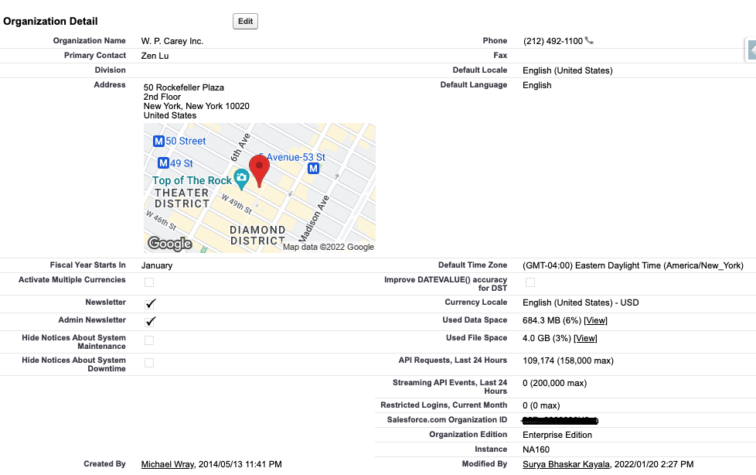

## org limits

Given the multi-tenant nature of Salesforce, many org limits apply. The full list of limits that have been evaluated are shown in Appendix 8.3, the key limits impacting current and future state are described in more detail below.

### Data Storage

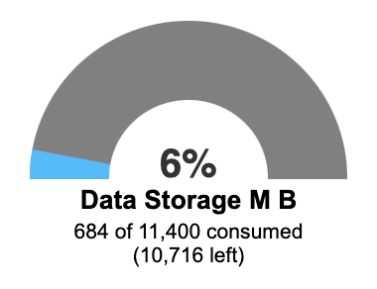

Available data storage = 10GB (data storage minimum per org) +

1160 MB (58 users x 20MB/user)

11.1GB total

Used data storage = 684.3MB / 11.1GB or 6%

### Data Storage Observations

#### Given the current data storage usage after 8 years of existence, the org has more than sufficient data storage capacity to handle many more years of operation and additional business processes before it becomes necessary to implement any sort of archival or deletion policy to mitigate any large data volume (LDV) performance issues.

### File Storage

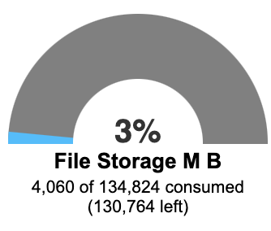

Available file storage = 10GB (data storage minimum per org) +

116 GB (58 users x 2GB/user)

126 GB total

Used data storage = 4GB / 126GB or 3%

### File Storage Observations

#### After 8 years of existence only 3% of the file storage is used. This is due to relatively small number of files in the org, together with the implementation of the “[Document Extractor](https://appexchange.salesforce.com/appxListingDetail?listingId=a0N3A00000EtE8uUAF)” AppExchange app which moves the file content from Salesforce into SharePoint.

#### Given the current file storage usage after 8 years of existence, the org has more than sufficient file storage capacity to handle many more years of operation and to onboard additional business processes. SharePoint is already in place to handle archival of files should this become necessary at some point in the future.

### Daily API Requests

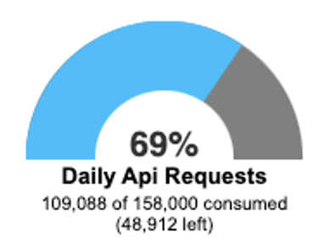

Available API requests per 24h = 158 000

Used daily API requests (as on 25 July 2022) = 109 088 or 69%

### Daily API Requests Observations

#### Based on [Enterprise edition API allocations](https://developer.salesforce.com/docs/atlas.en-us.200.0.salesforce_app_limits_cheatsheet.meta/salesforce_app_limits_cheatsheet/salesforce_app_limits_platform_api.htm), the org should have only 58 000 API requests available per 24h (58 users x 1000 API requests / user). The current limit showing in the org is 158 000, indicating that additional API requests may have been purchased.

#### Reviewing the 7 day API usage report in Salesforce, it appears that the majority of API calls are being consumed by the “Document Extractor Prod” user, presumably as part of the on-demand mechanism by which files are moved from Salesforce to Sharepoint.

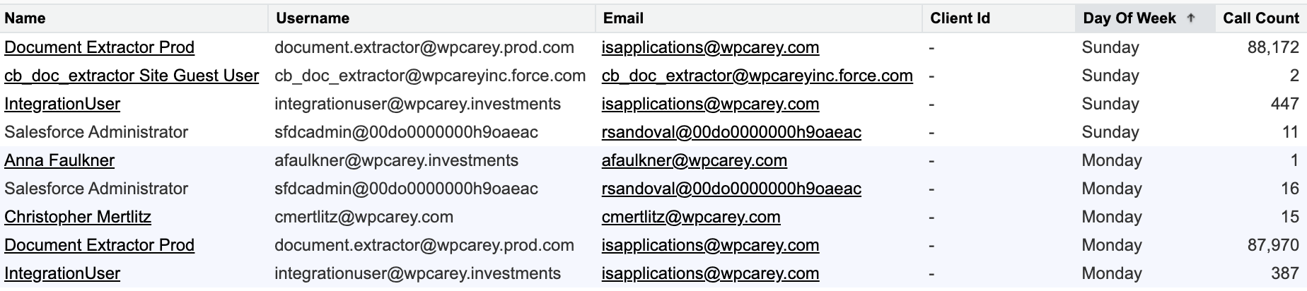

Figure 1 7 Day API Usage report

### Daily API Requests Recommendation

#### While there doesn’t appear to be any immediate risk of exceeding the daily API requests limit (and the limit is also a soft limit that isn’t immediately enforced), it is recommended to setup an API usage email alert to a designated system administrator as described in [Salesforce documentation](https://developer.salesforce.com/docs/atlas.en-us.200.0.salesforce_app_limits_cheatsheet.meta/salesforce_app_limits_cheatsheet/salesforce_app_limits_platform_api.htm). This will provide a proactive warning if API limits are being approached for any reason.

# security

## release updates

There are 2 overdue release updates as shown in Figure 2 below.

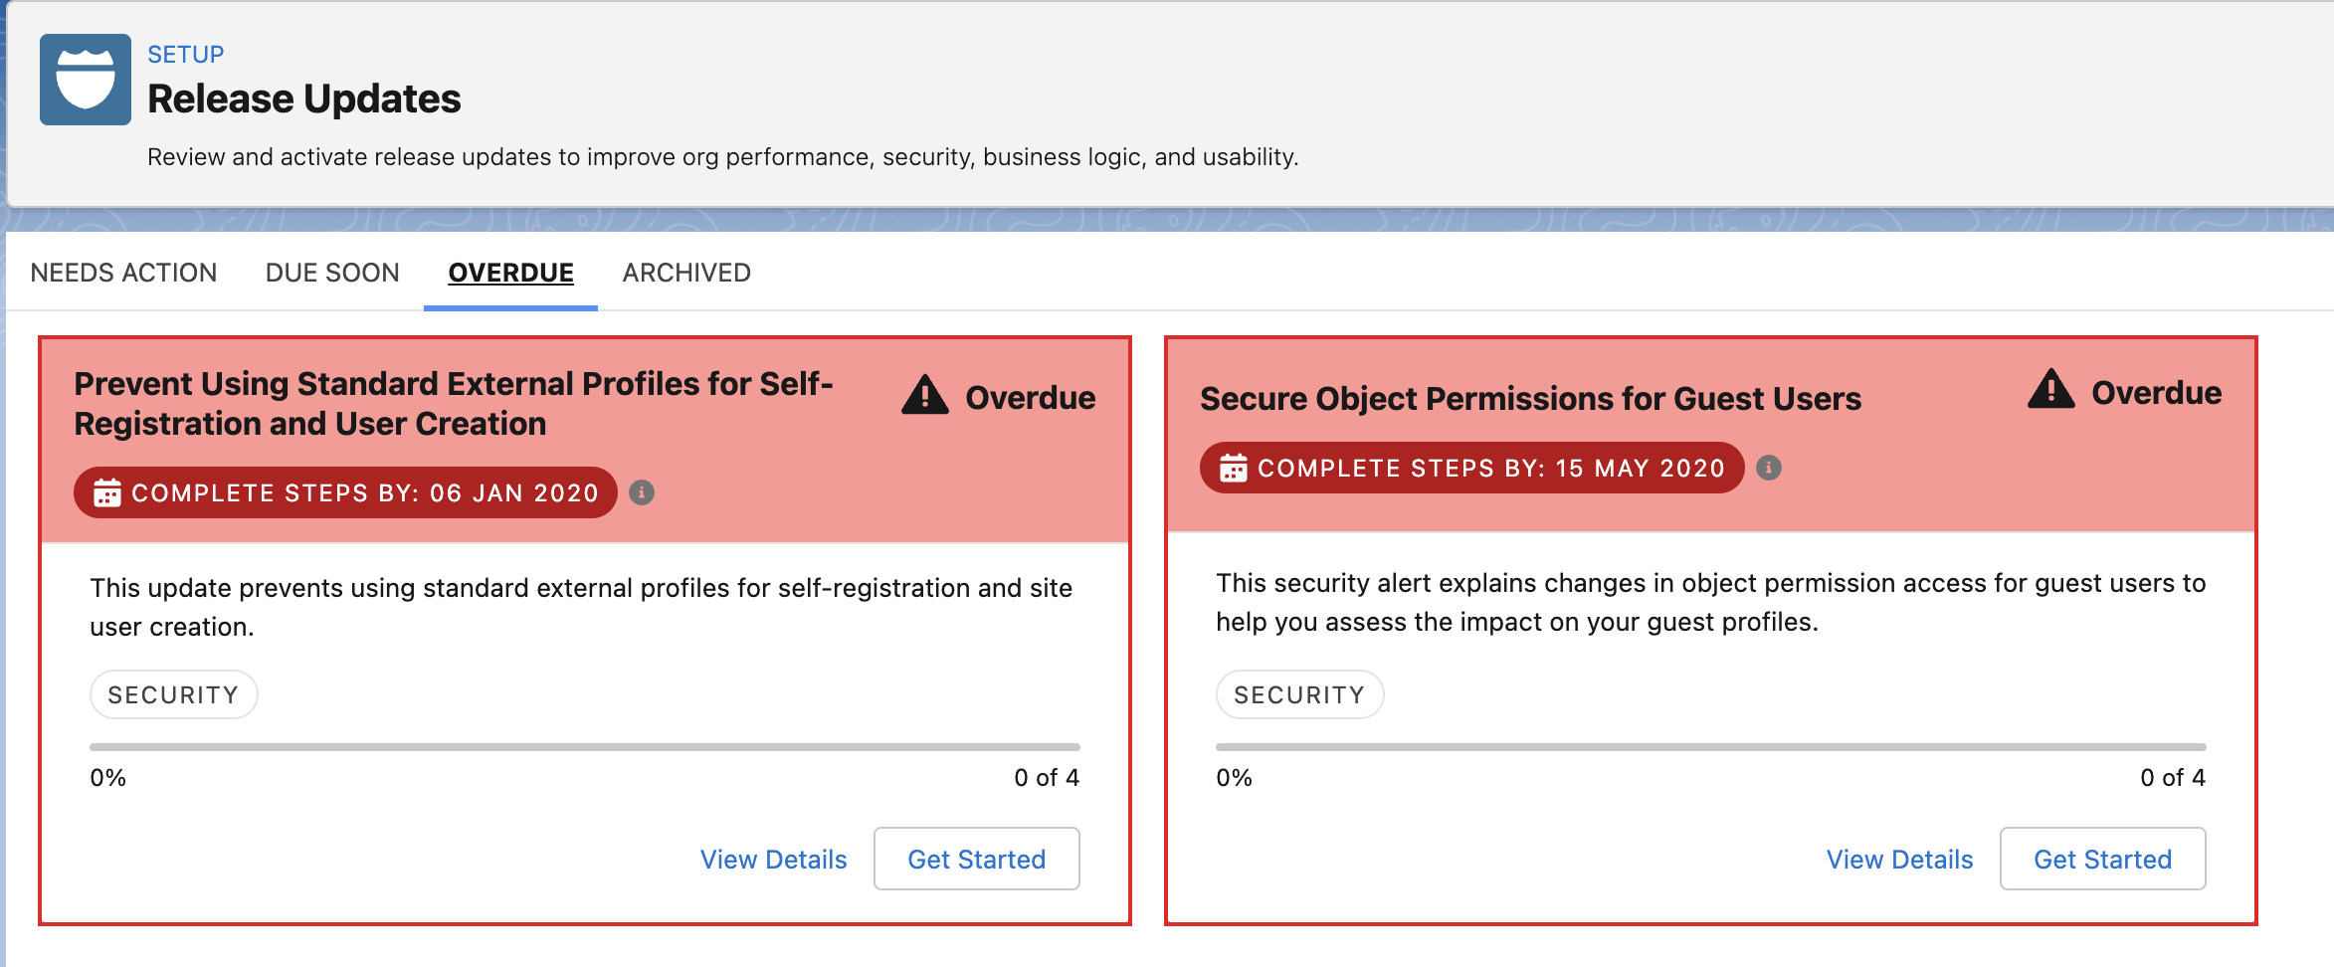

Figure 2 Overdue Release Updates

### Release Updates Recommendation

#### Release updates are recommended by Salesforce to ensure the overall security of the system and should therefore be applied within the suggested time period. The updates shown above are both related to external users for communities and sites. While the org doesn’t have any community user licenses assigned, it appears that the guest user is being used for the communities and sites shown in Figure 3 below.

Figure 3 Sites and Communities

#### It is recommended that these updates should be applied as soon as possible within the standard maintenance cycle applied to the org. These changes should be applied first in a sandbox and the sites and communities in Figure 3 above tested in this sandbox to ensure they are not negatively impacted.

## profile permissions

The profiles shown below have been granted the “Modify All Data” and “View All Data” permissions. These permissions give access to all data within the org and typically should only assigned to System Administrators.

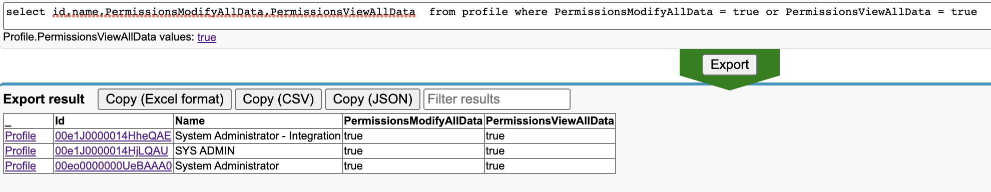

Figure 4 Profiles with ModifyAllData permission

### Profile Permissions Recommendations

#### It is recommended to review the users assigned to the custom profiles shown in Figure 4 above (namely “SYS ADMIN” and “System Administrator – Integration”). If these users are System Administrators, they should be assigned the standard System Administrator profile. Otherwise they should be assigned to a profile with less access. See 3.4.1.2 for recommendation on profiles for API integrations.

## user provisioning

As per Figure 5 below, there are a small number of active users who have not logged in recently.

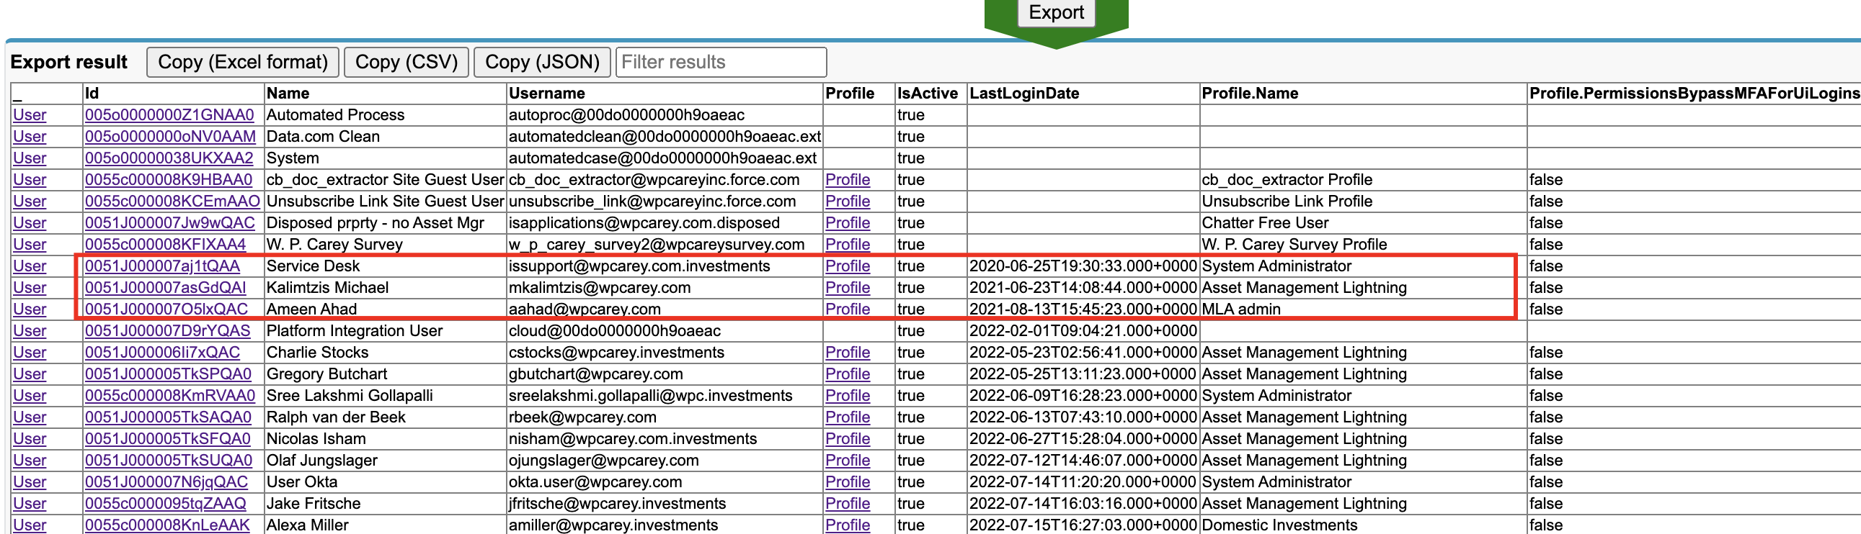

Some users remain active despite no recent logins

Figure 5 Active users with no recent logins

Based on analysis of the SetupAuditTrail which shows the previous 6 months’ history, Salesforce users are being manually provisioned and de-provisioned.

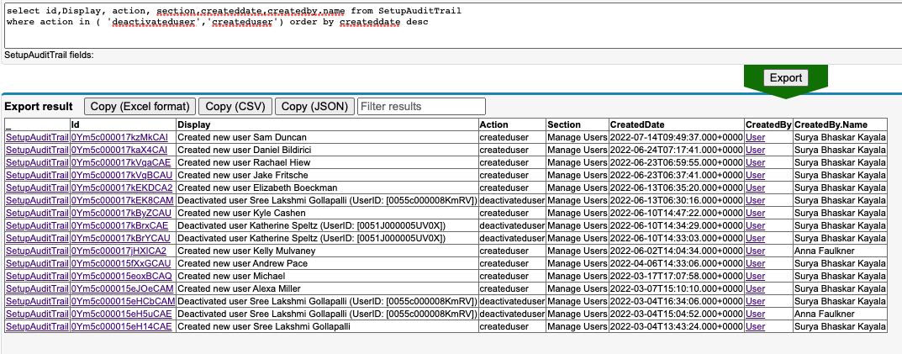

User provisioning is being done manually by sys admins

Figure 6 SetupAuditTrail entries for user provisioning

### User Provisioning Recommendations

#### It is recommended that users who have not logged in for more than 3 months should be deactivated in order to optimize license usage and also prevent an unused user becoming a vector for a malicious attack. This deactivation can be done by manually via a quarterly report run by a sys admin.

#### While the volume of user provisioning events is relatively low, it is recommended to use an automated process to manage this, especially on the deactivation process. This ensures that employees’ Salesforce licenses are automatically deactivated on termination of their employment. Given that Okta is already being used for Single Sign On (SSO), automated user provisioning could be achieved with [Okta Salesforce User Provisioning](https://help.okta.com/en-us/Content/Topics/Provisioning/Salesforce/sfdc-enable-provisioning.htm#:~:text=To%20edit%20the%20Okta%20to,list%20and%20then%20click%20Edit.)

## system administrator audit

There are 9 users configured with the System Administrator profile as per Figure 7 below. It appears that a number of these users are used by integrations rather than actual system administrators.

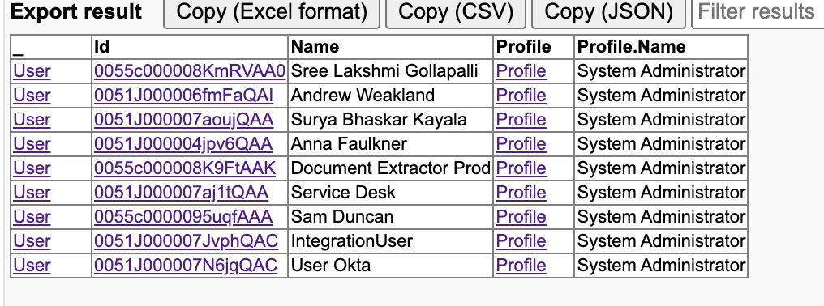

Figure 7 System Administrator users

### System Administrator Recommendations

#### Each of the System Administrator users above should be reviewed to determine if they are genuinely system administrators with the requisite Salesforce experience to be responsible for a production org.

#### API integrations should not be setup to use System Administrator profiles as this poses a number of security risks as outlined [here](https://medium.com/salesforce-architects/security-best-practices-for-api-access-and-internal-system-users-a6199d0cda09). Instead a base profile should be created for all API integrations and the permissions required for each specific integration should be assigned via a permission set (including IP range restrictions).

## allowed email domains

There is currently no restriction on domain names that users can use for their email addresses, as shown in Figure 8 below.

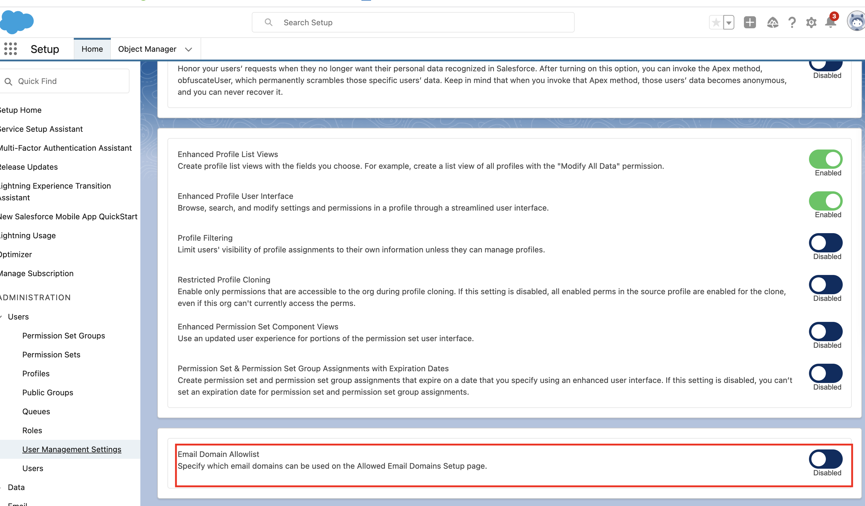

Figure 8 Email domain allowlist

### Allowed Email Domain Recommendations

#### Although user authentication is secured via SSO with Okta, it is recommended that only specified email domains be allowed. This will further reduce the possibility of any user license being used to gain malicious access to the org.

## single sign on and multifactor authentication (mfa)

Single Sign On (SSO) is required for all users (excluding System Administrators). Okta is being used as the IdP to facilitate SSO and is enforcing MFA, hence W.P. Carey is compliant with [Salesforce’s MFA requirements](https://help.salesforce.com/s/articleView?id=Salesforce-Multi-Factor-Authentication-FAQ&language=en_US&r=https%3A%2F%2Fwww.google.com%2F&type=1#:~:text=to%20Enable%20MFA-,Is%20Salesforce%20requiring%20customers%20to%20enable%20MFA%3F,use%20MFA%20for%20every%20login.).

## org wide default sharing model

The org wide default (OWD) for a number of objects is set to “Public Read/Write”, both for internal and external access.

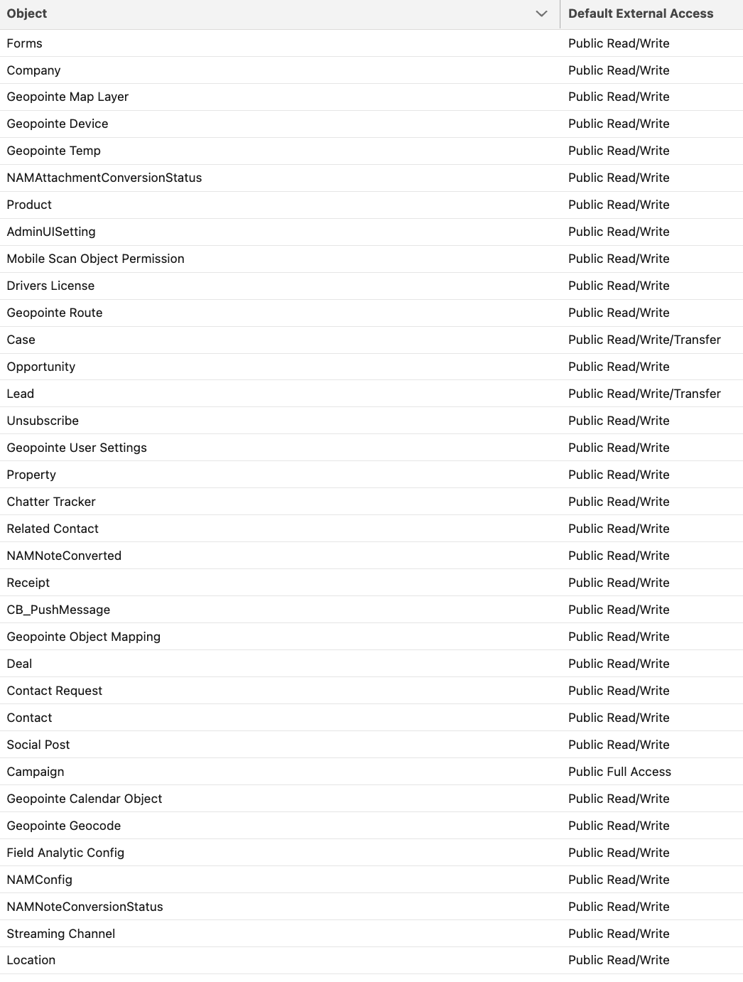

Figure 9 Objects with Public R/W OWD for external access

### Org Wide Default Recommendations

#### Depending on the business requirements, internal users may require public read/write access to an object. However, it is recommended to apply the principle of least privilege and ensure that users have access only to the data relevant to their role and responsibilities. This reduces the risk of data loss (e.g. a disgruntled employee exporting all opportunity and contact data) and data security (e.g. certain financial data may be confidential).

#### The default OWD for external users should be changed to “Private” for all objects as matter of priority. For the objects needed for site and community functionality (see Figure 3), guest user sharing rules should be setup to provide the required level of access.

# apex code

## code quality

Based on the results of Apex PMD static code analyser (see Appendix 8.1 for full details) a number of issues have been flagged.

### Apex Code Recommendations

#### It is not recommended that all issues in the PMD output need to be resolved as this would involve significant development work for little tangible value to the business. However, some of the more important issues could be included in a backlog and delivered over time to improve the robustness and quality of the code. Some candidate issues are shown below

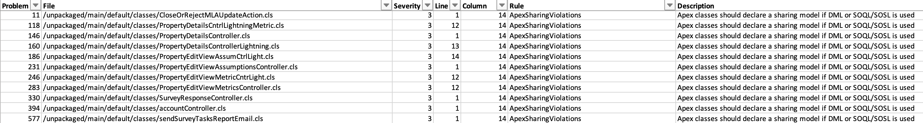

Figure 10 Sharing model for SOQL/SOSL – helps to avoid giving unintended data access

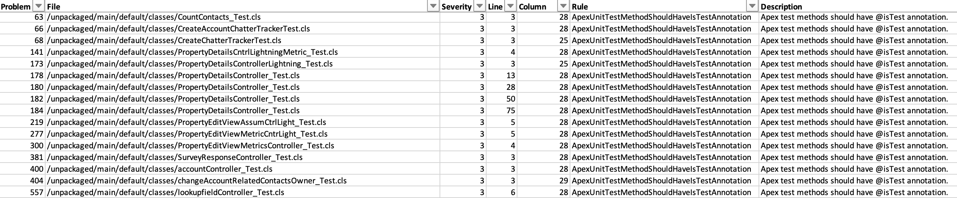

Figure 11 Test class annotation – helps to exclude test code from counting towards Apex code limit

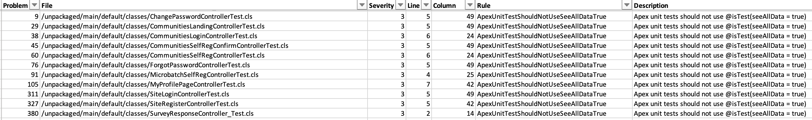

Figure 12 Test data visibility – helps to ensure test classes complete successfully on all environments

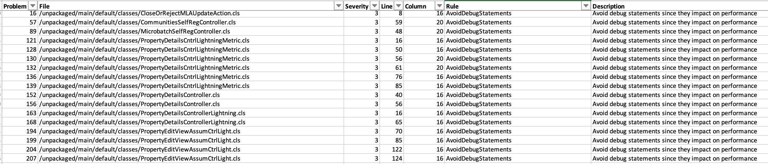

Figure 13 Avoid debug statements - improves performance



Figure 14 - Avoid unescaped variables - prevents SOQL injection attacks

## test code coverage

Test code coverage is at a healthy 91%, but 5 tests are currently failing as per failures shown below

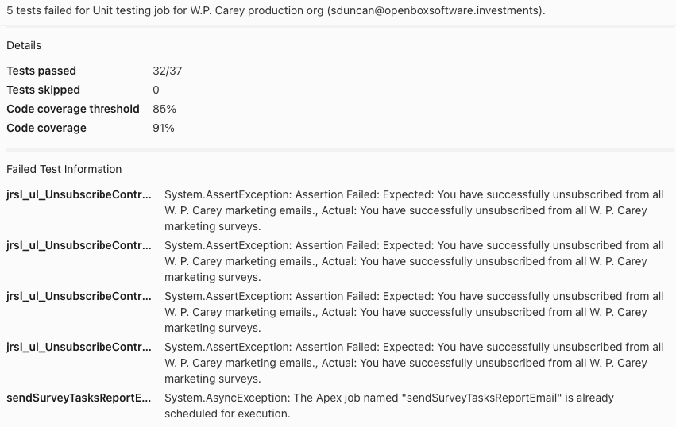

Figure 15 Test code failures

### Apex Code Recommendations

It appears that the test failures are mostly due to minor changes in the text value expected by the assertion. This should be a relatively trivial test class to correct and should be done as part of the backlog. It is important to have all tests running successfully in production.

# sandbox and deployment strategy

## sandbox usage

There are 3 sandboxes currently available as per Figure 16 below. It is interesting to note that W.P. Carey has a full copy sandbox (“TEST”) which normally comes at significant cost. Based on the data in the production org (less than 5GB) this could be accommodated in a partial sandbox.

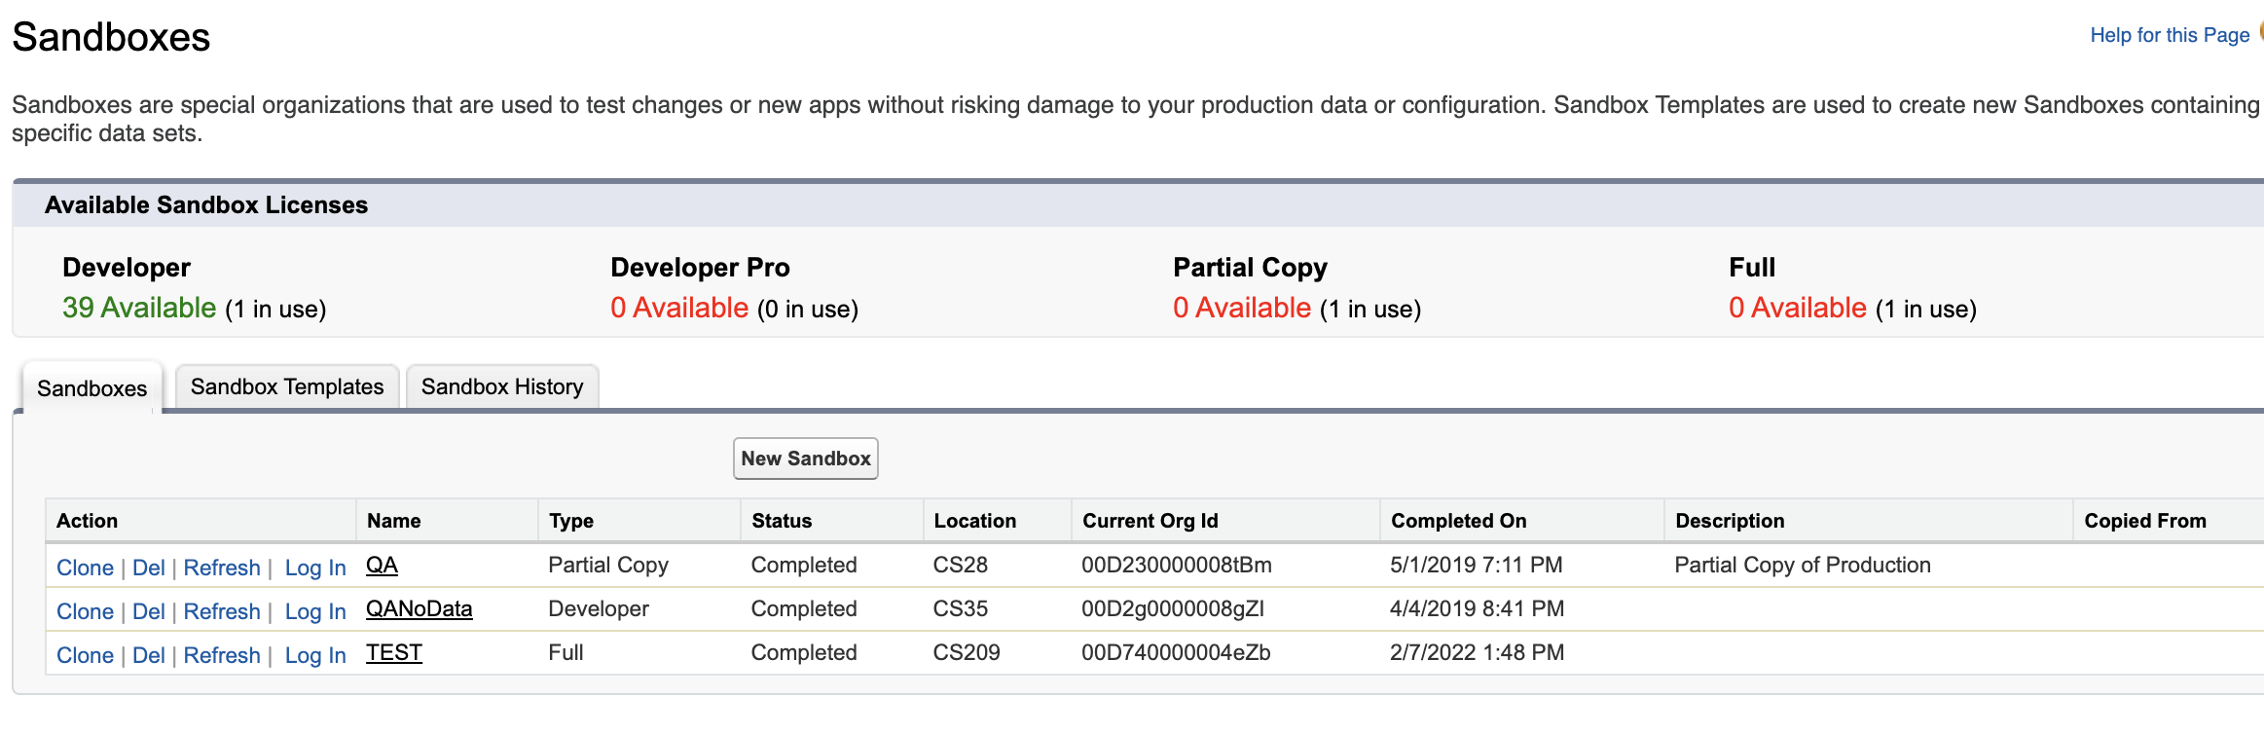

Figure 16 Sandboxes

### Sandbox Recommendations

#### The “TEST” sandbox was last refreshed in February 2022 and ideally would be scheduled for another refresh soon in order to ensure that it accurately matches the production org in terms of data and configuration. This refresh should be planned with consideration of Salesforce release dates and preview windows.

#### The other two sandboxes (“QA” and “QANoData”) were refreshed in 2019 and are likely to deviate significantly from the production org. Plans should be made to refresh these sandboxes (or create new sandboxes as per 5.1.1.3).

#### Ideally the development lifecycle for Salesforce features would see configuration being done in a “DEV” sandbox, deployed to a “QA” sandbox for quality assurance testing and then deployed to a “TEST” (or “UAT”) sandbox for end users to complete user acceptance testing.

#### Depending on the environments available for other applications (e.g. One Cloud) in the W.P. Carey landscape, Salesforce sandboxes should be setup to match the test environments of these applications. This will allow end-to-end testing to ensure changes made in Salesforce do not have downstream impact and vice versa.

#### Depending on the release strategy, plans should be made to have all sandboxes refreshed more regularly.

## deployment methodology

Through analysis of the SetupAuditTrail and DeployRequest, it appears that most changes are deployed to the production org via a changeset from the “TEST” full copy sandbox. However, there are some changes (an example of which is shown in Figure 17 below) that appear to be made manually in production without any DeployRequest. Based on this, it would seem that there is no formal release process that requires changes to be tested first in a sandbox and then deployed to production.

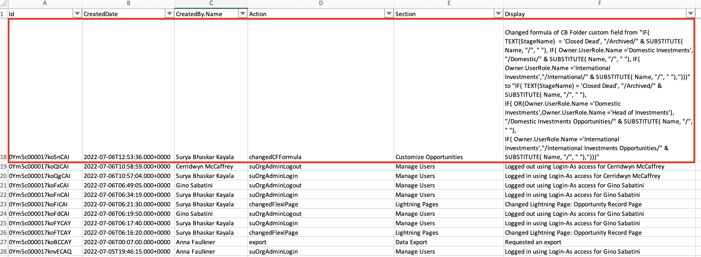

Figure 17 Field change made directly in PROD

### Deployment Recommendations

#### If not already in place, a release strategy should be defined whereby all Salesforce changes are tested and signed off in test environments and deployed to production via the metadata API (Changeset or ANT). Manual changes directly to production should be avoided except for critical fixes.

#### In the longer term W.P. Carey should consider implementing a CI/CD process with version control. While this can have a steep learning curve in the beginning, it helps to establish a robust software development lifecycle that can deliver new Salesforce functionality reliably and repeatedly.

# license usage and adoption

54 of the 58 Salesforce licenses available in the org are assigned to users. Keeping 4 licenses available for new starters will be helpful in ensuring that new starters can be assigned a Salesforce license with minimum delay. Based on user login history, 46 of the users (85%) have logged in during the past two weeks, indicating a good level of user adoption.

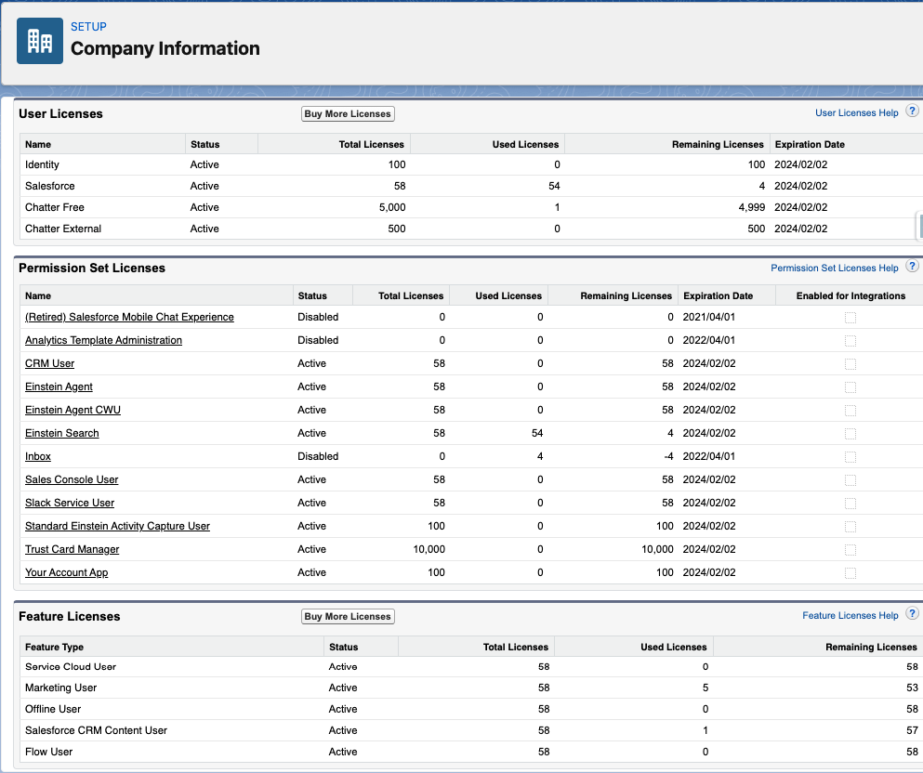

Figure 18 License Information

# general observations and summary

The W.P. Carey Salesforce production org was provisioned in May 2014, making it a relatively mature application which has supported the business for over 8 years. Given this length of service, the org is in good technical shape and there are very few urgent issues that require immediate attention. It appears to be a robust org that is ready to onboard more business processes, more users and more data.

# Appendices

## Apex PMD static code analysis output

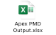

## salesforce optimizer xls file

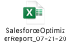

## ORG limits

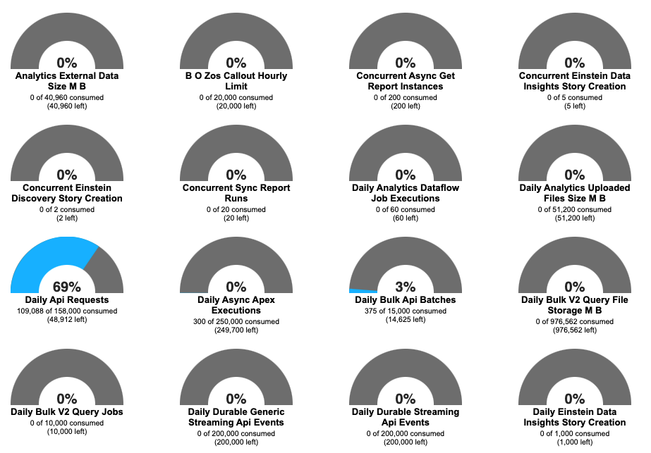

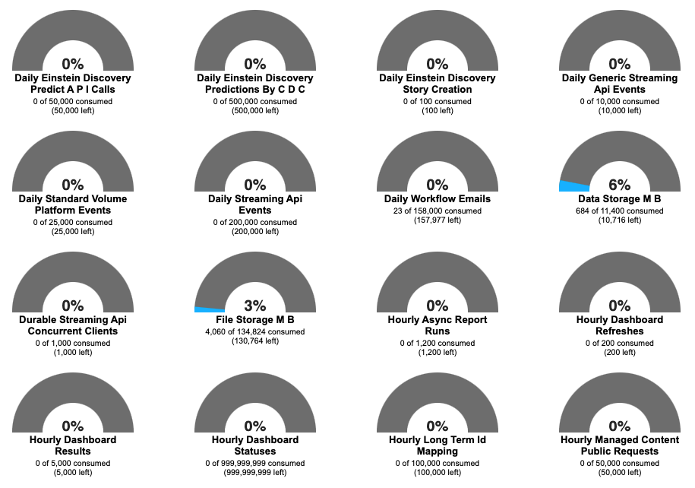

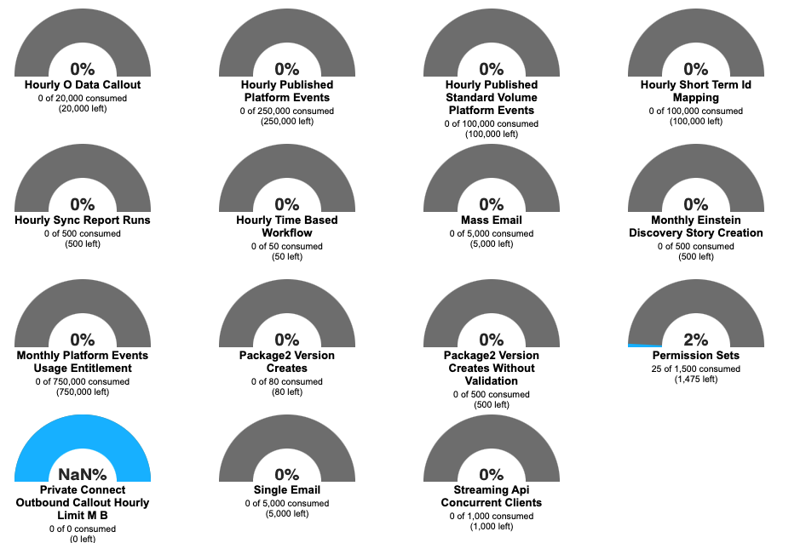

## Storage limits

### Data Storage

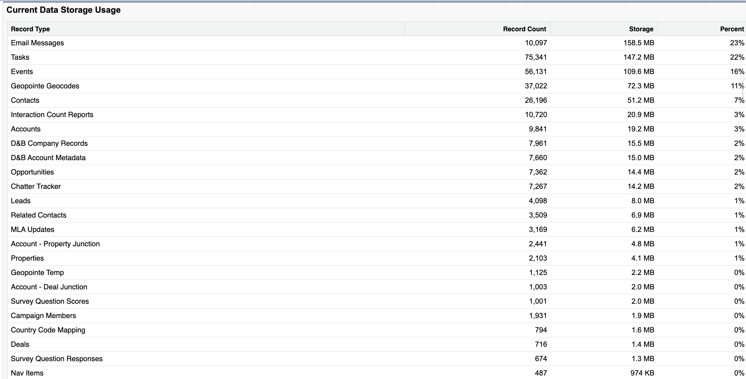

### File Storage

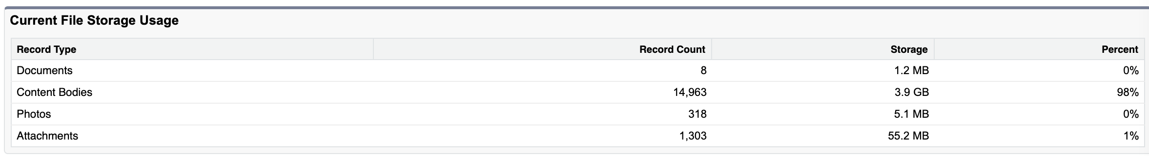

### API Usage in last 7 days

The report below shows SOAP API usage over the past 7 days (as of 25 July 2022). Note that REST API calls are not shown, it is assumed that REST API calls account for the difference in the reported API usage in 2.1.5 above vs. the usage figures shown in the report below.

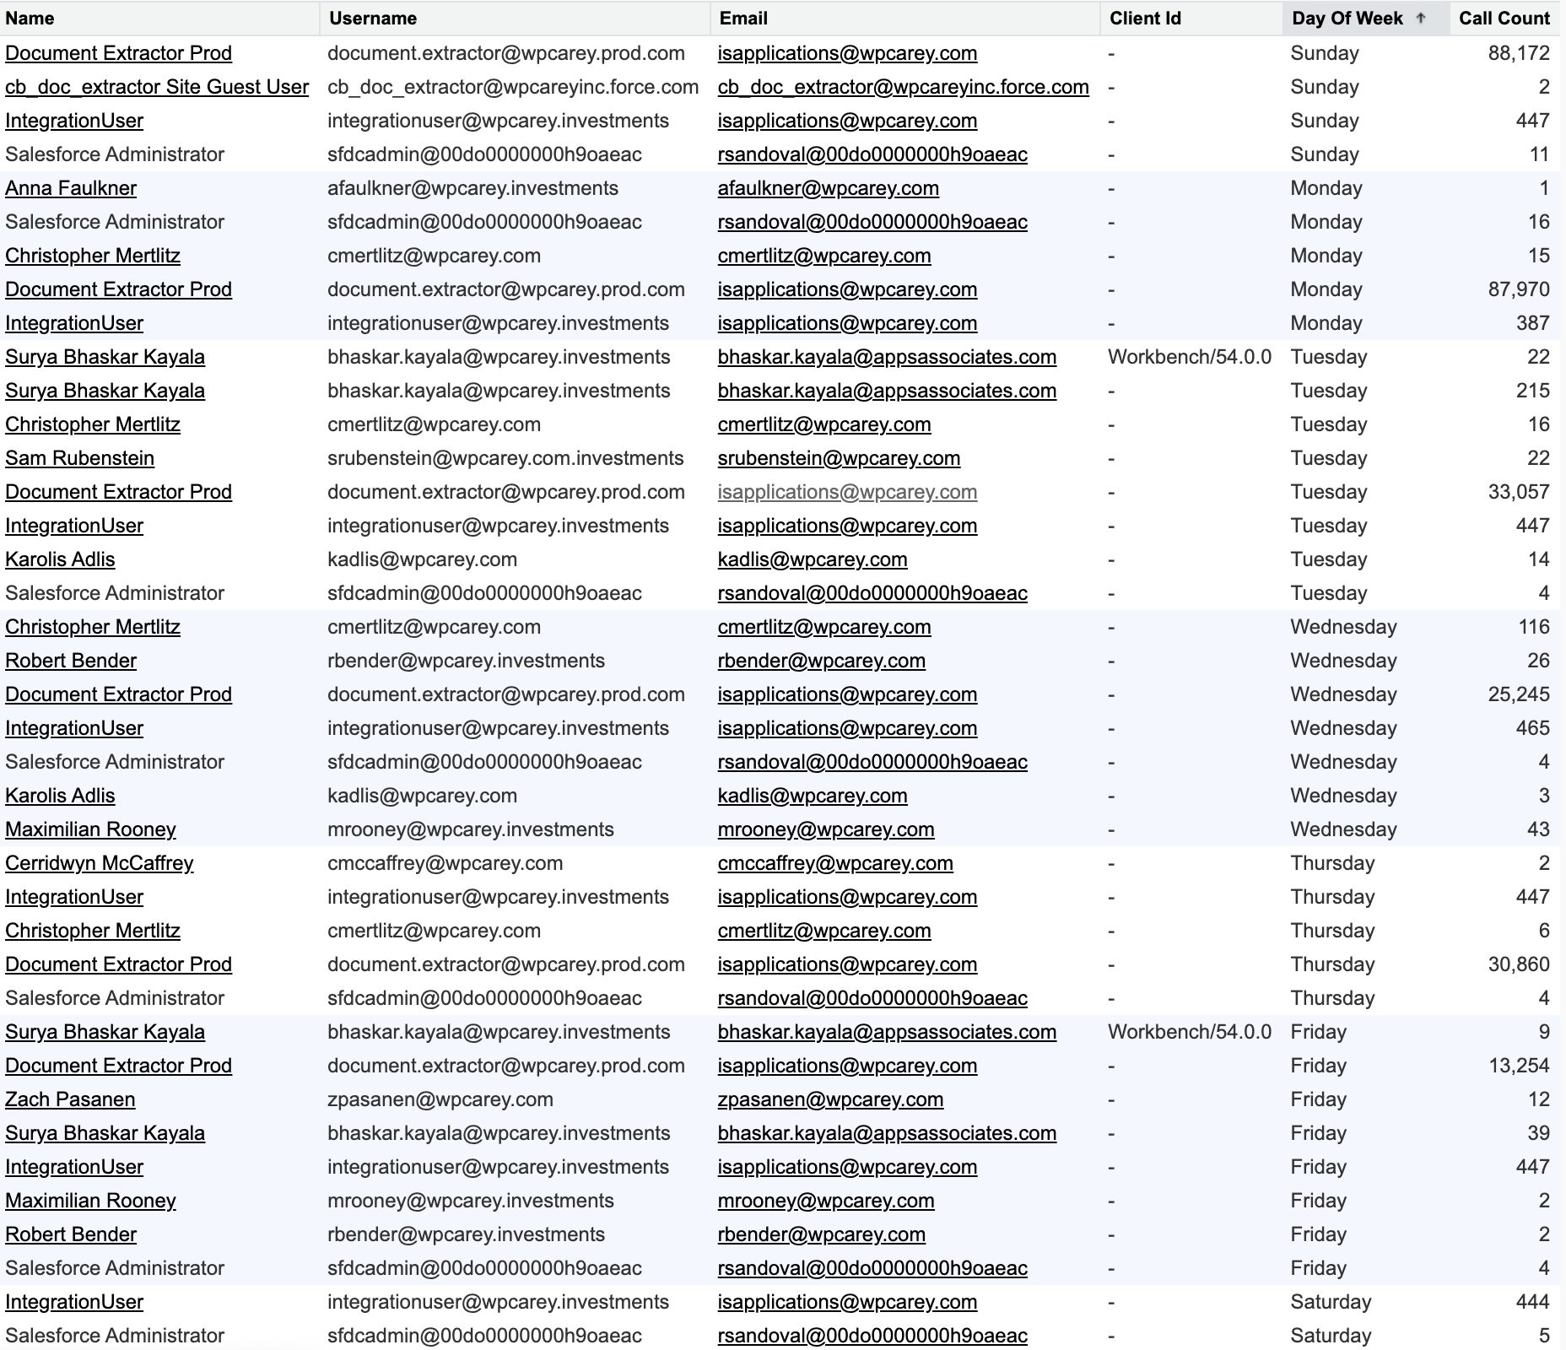

## misc data

The spreadsheet below contains data from various SOQL queries used in the assessment.

